Building Your Web of Support
First, on a separate sheet of paper write the first names (or initials) of family and friends and other people who you feel have been most important to you and most helpful to you. Be sure to include names of those you spend most of your time with, feel close to, and who you turn to for different kinds of help or support.
Second, add each of these people on the web diagram below (write or use small sticky notes):
- Begin to locate the name or initials of each person near the place where you most often see them (for example, school, neighborhood, home/family). People seen outside of school or home go near the top.
- Decide how important to you (at the center) they are. Place near the center (close to “You”) those people with whom you have the strongest relationship. Usually these are the people you feel closest to and spend the most time with. Place those you see less often and feel least close to near the outside ring.
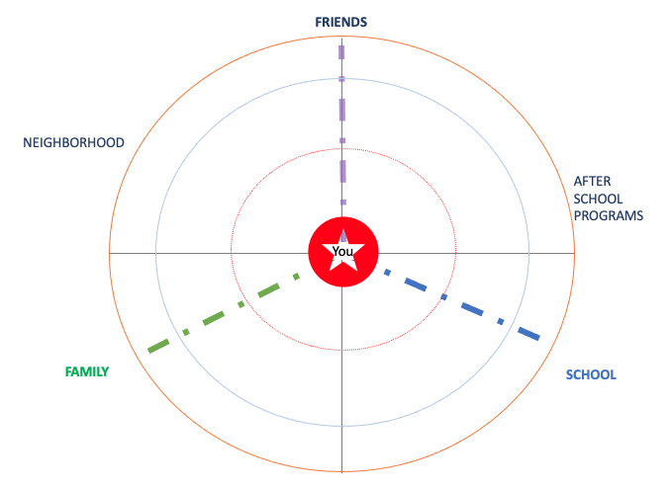
Options: (1) If people on the map know each other, draw a line to show this connection. Now it’s a web. (2) Put an A next to any person who is your “anchor,” your go-to person for support; (3) Write the letter(s) next to each person to show the kind of support they provide you: e: emotional t: things/resources i: informational f: feedback c: companionship

Building Your Web of Support: Interviewer Guide
Interview Part 1: Introduction of Task and Defining Social Support
Provider-Interviewer Prompts: Introducing the Interview
“We are going to spend some time now talking about some of the people you know. I would like to get an idea of which family and friends and other people you feel have been most important to you and most helpful. To begin with, I am going to ask who you spend time with, are close to, and who you turn to for different kinds of help. You can give me just their first names or their initials if you wish, and I will write them down on this list.*
Do you have any questions?”
* Note: Who writes the names (and where): Interviewer can write names on a separate sheet of paper, or youth or interviewer write them on small sticky circles that can be later applied to the Web diagram.
Provider-Interviewer Prompts: Defining types of support for youth
“Think about who are the people you feel have been important to you for help or for spending time with. They may give you a shoulder to lean on when you are feeling down; help you to figure out how to do something like completing your homework or filling out college applications; give or lend you things you need like food, clothes, or money; spend time with you like by playing basketball, just hanging out or going with you on a job interview or to visit a college; or they give you feedback on how you are doing or cheer you on in whatever you do in life.”
Provider-Interviewer Prompts: Requesting names of supportive “actors”/individuals
“First let’s name important people at school who have helped you or who you spend time with….
Now, name supportive friends and adults in your neighborhood…
…Family…”
Note: Order of prompts for Adults, Peers, and Supportive people from the Past: First, ask for names of up to 6 supportive adults; Then, ask about supportive peers; Last, ask about any people not close to or seen infrequently, but who the youth was close to or saw frequently in the past or could be helpful in the future. The rationale is that the web is most useful when currently and previously supportive individuals are identified.
“Are there important people who have supported you at a Workplace or Job or in an After-School Program or other place where you spend a lot of time?”
“Are there supportive people from your past to whom you could turn for help today?”
Interview Part 2: Web building activity: “Building Your Web of Support”
“Now let’s organize these names in a Web of Support. Here’s an example of what a Web might look like” (Provide youth Handout on p. 4 and Web Diagram on p. 1). Introduce terms in the Handout, and then guide the youth through the instructions for the Activity. Once the Web is built, move to Part 3.
Interview Part 3: Describing Relationships on the Web
“For this last part of our interview, I want to make sure I understand your Web and your relationships with the individuals in it. Can you tell me more about these individuals?
What is the role each person plays in your life (e.g., parent, teacher, coach, friend)?
Tell me what type of support or help they provide you (You can refer to the definitions in the Handout. You can also restate the earlier examples, this time with labels indicating the types of support.)

“They may give you a shoulder to lean on when you are feeling down (emotional support); help you to figure out how to do something like completing your homework or filling out a college applications (informational support); or give or lend you things you need like food, clothes, or money (things and resource support); they may give you feedback on how you are doing or cheer you on in whatever you do in life (feedback support); or they just spend time with you, like by playing basketball, just hanging out, or would go with you on job interview or to visit a college (companionship).”
Is anyone here a “go-to” person for you? We call that person an “anchor”. Anchors provide, or they would provide, all five kinds of support and so are people you could go to for anything. If any of the people you identified are an anchor for you, put an “A” by their name on your Web.
Having placed people in their setting, located by strength of relationship, and (optional) linked with lines, ask the young person what types of support they provide the youth or have provided in the past.

For each person they placed in the web, ask them about why they placed them where they did. Example prompts:
Tell me about why X is placed here? What is it about X that makes you feel that close to him or her?
You placed X near you and Y at the edge of your web, can you tell me about how those two are different from each other? How are your relationships with these two people different?
If there are no people that are rated low (i.e. if everyone is in or near the center circle) ask:
“Are there any people in any of these settings who you’d say you are not close to?”
Optional prompts for mapping: Once finished asking questions, ask youth if any individuals should be moved (closer or away from center), deleted, or added to the Web Diagram.

“Looking back at the Web of Support you made, now that we’ve discussed all of these individuals, would you move any of them closer to you on the Web or closer to each other because of how often the individuals interact with each other or how close they feel to each other?
“Is there anyone left off?”
Youth Handout:
Example Web of Support
(once people are placed)
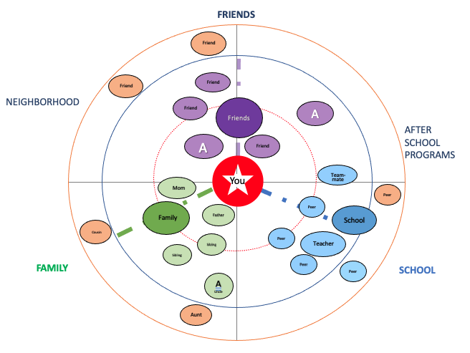
Notice, at the center of the Web are people youth are closest to and interact with regularly (in person or by text); toward the outside are those people who youth see rarely or infrequently and feel less close to.
The “A” stands for “anchors”—people youth can go to for anything. They provide many types of support and make youth feel heard and that they matter.

Social Supports: Definitions & Examples
(e) Emotional: Expresses caring, comfort, and trust. Examples: listening, giving advice, checking-in, acceptance
(t) Things/Resources (Instrumental): Provides tangible resources or services. Examples: providing a bus pass or meals; babysitting so that a parent can attend school; taking a young person to visit a college campus
(i) Informational: Offers advice or insights (for example, to help youth reach goals). Examples: provides information on how to re-enroll in school, where to find a job, or how to complete a job application
(f) Feedback (Appraisal): Gives feedback that a young person can use for self-evaluation, such as affirming a young person’s competence by pointing out specific strengths or providing constructive criticism. Examples: provides encouragement, positive reinforcement
(c) Companionship: Provide partner for activities. Examples: going to the movies or a sporting event.

